Title
  - Author first name, AUTHOR SECOND NAME, Affiliation, e-mail address
  - Author first name, AUTHOR SECOND NAME, Affiliation, e-mail address

Abstract
The abstract should summarize the contents of the paper in short terms, i.e. max. 200 words! Please insert it here. The abstract will be published in the book of abstracts.
Keywords: First Keyword, Second Keyword, Third Keyword, Fourth Keyword, Fifth Keyword

Heading 1
Please note that the paragraphs are not indented, and sections are not numbered.

Heading 2
Please note that the paragraphs are not indented, and sections are not numbered.
Please see below how to insert figures (Figure 1) and tables (Table 1) in the text.
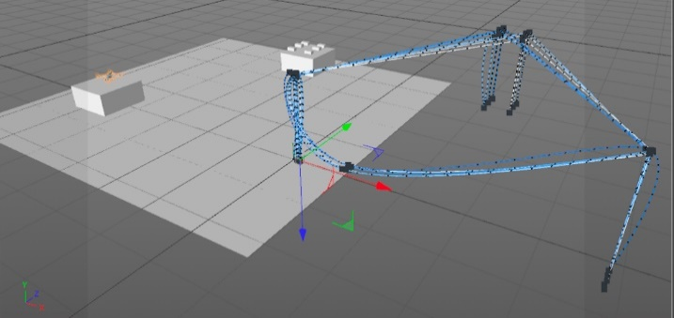
Figure 1: this is the caption of Figure 1
Table 1. Table captions should be placed above the tables
Results | Results | Results
Results | Results | Results
Results | Results | Results
Results | Results | Results
Results | Results | Results
Results | Results | Results

References should be included using Harvard style like (Milgram et al., 1994) and (Slater and Usoh, 1994).

References
Milgram, P. et al. (1994) ‘Augmented Reality: A class of displays on the reality-virtuality continuum’, Systems Research, 2351(Telemanipulator and Telepresence Technologies), pp. 282–292. doi: 10.1.1.83.6861.
Slater, M. and Usoh, M. (1994) ‘Body centred interaction in immersive virtual environments’, Artificial life and virtual reality, 1, pp. 1–22. doi: 10.1.1.109.7613.

